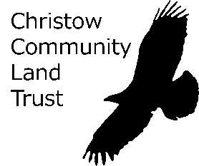

CHRISTOW COMMUNITY LAND TRUST

Minutes of the Annual General Meeting held on Thursday 16th September 2021 at the Teign Valley Community Hall

- Welcome, introductions and apologies

Present:
Board members: Maggie Bonnell (Secretary); Penny Clapham (Treasurer); Andy Cook (Membership Secretary); Tim Deane (Vice Chair); Jo Twelvetrees (Minutes) .
Members: Tom Archer, Tony Clapham, Tony Cook, Audrey Cowlard, Peter Cowlard, Jan Deane, Tristan Deane, Jude Jones, Andrew Wise
Welcome to all present by Tim Deane who chaired the meeting in Corony Edward’s absence.

Apologies received from: Corony Edwards (Chair); Mike and Sheila Wharton; Lyn Shackleton; Jill and Philip Arthur; Jeston Brightmore-Armour; Sarah Rice

- Minutes of the Annual General Meeting of 17th September 2020

The acceptance of the minutes was unanimously approved, with Tony Cook as proposer and seconded by Tristan Deane.

- Matters arising from the minutes

Attention was drawn to item 5 and Tony Cook’s query as to the CCLT’s requirement to pay corporation tax. The chair reported that advice had been sought from Steve Watson (Wessex Community Assets/Middlemarch). He explained that, as the CCLT is receiving an income and is therefore classed as trading, it cannot avoid paying corporation tax, unless a separate charity is set up to which is made over the trust’s income. The work and expense of this would exceed any benefit.

- Chair’s Report on the work of Christow Community Land Trust over the past year

The following report was read out by the Vice-Chair:

Christow Community Land Trust
Chair’s annual report 2021
I am pleased to report that during the past year our Community Land Trust has continued to deliver on its objective to improve the physical, social and economic infrastructure within Christow and the surrounding area in spite of the ongoing Covid-19 pandemic and the various restrictions this has placed on our lives.
Like most groups we moved to online Zoom meetings for most of the period so it is very good to be able to meet face to face again at this AGM.
I’ve divided my report into three main themes this year: people, money and projects.
First, people: I’d like to welcome Sam Henderson to his first AGM with us. Sam was co-opted in April 2021 to fill a vacancy on the board. As a co-opted member he is today standing for election as a full member of the board. He has already proved to be a very valuable member of the team with far better knowledge of housing development and planning policy than any of the rest of us so I do hope you will give him your support.
I should also at this point report Graham Thompson’s resignation in April this year and thank Graham for his many years of service as a director of the CCLT. Thanks are also due to Andy Cook for stepping in to take over the duties of Membership Secretary from Graham.
In case you don’t know who else does what on the board, Tim Dean is our Minutes Secretary and Vice-chair, Maggie Bonnell is Company Secretary, Penny Clapham is our Treasurer and Jo Twelvetrees is our remaining board member.
Jo, Andy and Penny are standing for re-election today and we have one candidate, Andrew Wise, standing for the remaining vacancy so we hope to start the new business year with a full quota of eight directors.
Last but not least, our membership has increased slightly since last year and we now have 140 shareholder members. We think it’s important that we have a good number of members who can vote at the AGM and who we can keep updated through our newsletter because this gives our work a strong mandate. Do please encourage others to join and let’s see if we can reach 200 by our next AGM.
Now onto money and related matters. As our Treasurer’s report shows, our finances are in good health and we are grateful to Penny for taking over the preparation of our annual accounts and tax return which will save us £200 a year in accountant’s fees. Penny has also completed the important job of updating our records with the Financial Conduct Authority so we can be confident that we are conducting our business in an orderly and legal manner.
We have awarded three community grants this year, totalling £1,300: Teign Valley Museum and Archive Trust received £500 to support their digital archive project, Christow School had £600 for a new shed for the school vegetable garden and £200 has been allocated for the redesign of the Teignvalley.org website which has spaces for new CCLT pages, Teign Valley Community Hall pages, and a welcome message and useful information for newcomers and visitors. TVCH and the Parish Council have also contributed £200 each to this work.
This brings me to projects. If you visited our stand at the recent community celebration day you’ll already know that we have been busy juggling a number of initiatives.
The ‘Welcome Letter’ project was led by Maggie, who worked with representatives from the Parish Council, Acorn Community Support and the church to produce a short welcome letter to print and post through the letterbox of newcomers to the parish. Please let Maggie know if you have new neighbours and we’ll get a letter to them. The letter directs people to the website, which I have been co-ordinating, and which we hope will prove to be a useful one-stop-shop reference site for everyone, not just newcomers.
Since our last AGM, we have made finishing touches to the Archers’ Walk footpath project: the steepest section has been regraded to even out the slope and remove the need for a handrail and we commissioned a mini-series of three short video films with accounts of the history, habitats and birds to be found on the site. This used up the last of the Dartmoor National Park funding that we were awarded for the project. The videos are hosted on the DNPA YouTube channel and the links will be sent out in the next edition of the newsletter.
Climate and environment: this project has been progressing slowly but we hope it will gather pace soon. On the suggestion of Sam we are planning a survey of land use in the Teign Valley indicating historic, current and potential features and uses. Sam has DEFRA permission to access their land-use data and a license from the Ordnance Survey so that the data can be mapped. Local farmers, ecologists and the History Group have all shown an interest. The intention is to create an evidence-base to help us, as a community, to initiate further projects and make good use of the new, more environmentally-focussed agricultural support and other schemes designed to address the climate and environmental emergencies.
And finally, as you know, in late 2020 we commissioned a housing needs survey in partnership with the Parish Council which revealed a need for 14 new affordable homes in Christow (50:50 rental and shared ownership) as well as 5 or so manageable homes for older residents. Teign Housing are keen to develop a handful of rental homes on the remaining small plot of council land below the play parks but they have no interest in the further affordable and down-sizing homes. We are therefore exploring the possibility of a separate project with a different developer to satisfy the remaining housing needs and are meeting regularly to take this forward. We will be working closely with Teign Housing and others to represent the interests of the community throughout the ‘Stafford Close extension’ project and it is likely that we will take ownership of the land from TDC as we did with Stafford Close. We’ll be keeping the community updated through Unity magazine and Parish Council updates.
Let me close by thanking all of my fellow Directors and you, the members, for your support over the last year and reminding you that you don’t need to be a board member to be involved in a project. We’d love to hear from you.
Corony Edwards September 2021

- Presentation of accounts and proposal for audit exemption

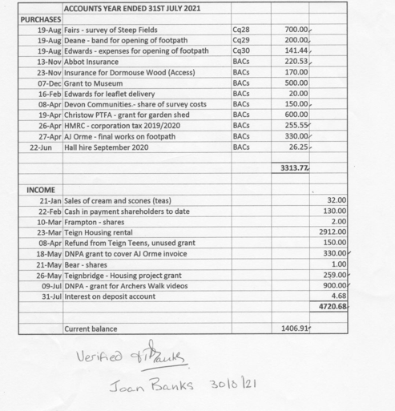

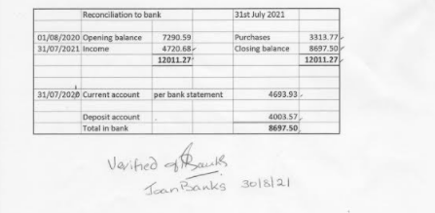
The accounts were presented by Penny Clapham. She explained there is no need for an audit as we have an examiner of accounts, Joan Banks, who has verified and signed the accounts. The sum paid to Abbot Insurance is for Public Liability Insurance, which is a legal requirement.

Acceptance of the accounts was proposed by Tim Deane, seconded by Jan Deane and unanimously approved.

An audit exemption was proposed by Tim Deane, seconded by Andrew Wise and unanimously approved.

- Appointment of examiner of accounts.

The reappointment of Joan Banks as examiner of accounts was proposed by Tony Cook and seconded by Tom Archer and unanimously approved.

- Questions from the floor.

Housing Survey
Tony Cook asked about the timescale of the potential housing development and the importance of timing for government grants was noted. Tim Deane informed members that Teign Housing is reserving a place in its development programme to ensure that the homes are complete by the end of 2023. It was clarified that the CCLT’s role is to aid communication between stakeholders and that the freehold of the land would be handed over to CCLT, hence there would be a small additional income for the CCLT. The development would be close to Passivhaus standards but would not be certified as such. It would consist of mainly small, one-bedroom units.

A question arose on the approximate rent for the 1-bedroom properties. Andrew Wise explained that the level depended on whether it was ‘affordable’ or ‘social’ rent, the latter being considerably lower.

Andrew pointed out the need for better understanding of the Passivhaus system as it was felt that Teign Housing had not provided sufficient guidance. There are still problems – e.g. higher than anticipated bills due to lack of understanding of the system’s correct use and misconceptions such as that windows should not be opened, even in the summer. Andrew kindly offered for people to contact him to learn more about best practice for Passivhauses.

Wet Lane / Dry Lane site
On the subject of further housing development, Tim Deane explained that the Dartmoor National Park Authority has recently produced a map showing the settlement boundary of the village. Being within this boundary the likelihood is that the Dry Lane / Wet Lane site would be developed sooner or later with or without CCLT involvement. Tom Archer informed the meeting that the site is already on the market. Tony Cook asked if the CCLT could buy this site but when it was suggested that the owner was aiming to achieve a figure of around £500K, it was clear that CCLT would not be able to afford it. It was also noted that CCLT are in preliminary discussions with another housing association about the development of this site. When asked about the role of CCLT in the housing development project, Penny Clapham explained that the CCLT was on the side-lines, listening in and guiding the process along the way, rather than spearheading the process. Andy Cook mentioned there had been some concern about the CCLT distancing itself from the project to avoid vilification, however members felt that the involvement of CCLT was important and meant a stronger chance that any development would benefit Christow residents.

The need to communicate with village residents from a very early stage was stressed by Tony Cook. Tim Deane informed the members present that a well attended question and answer meeting with representatives of TDC and TH had already been held. He confirmed that there was £25k available to the CCLT through TDC to cover legal expenses plus advice for the process from Steve Watson. Tony Cook said he was more than happy to discuss the lessons learned from the Stafford Close development process and pass this knowledge on to the current CCLT board. Tony's other suggestion was that we contact Dan Janota at DNPA to find out what the authority’s policies would be for development.

Mobile phone reception
The issue was raised of continuing poor phone reception due to the failure to erect a phone mast at Bennah. There was general support for the CCLT to seek to resolve this problem.

CCLT grants
The meeting agreed that the 50/50 split of the trusts available funds between its own projects and grant aid for other local initiatives was appropriate and should continue.

- Election of Directors (five vacancies - one due to resignation, one to approve co-option, three due to retirements by rotation)

Andy Cook, Jo Twelvetrees and Penny Clapham having retired by rotation were standing for re-election to the board. Andrew Wise was standing for the first time. Owing to the lack of a nomination form for Sam Henderson the meeting could not approve his co-option. The first four named were duly elected to the CCLT board without dissent.

- Close of Annual General Meeting

There being no further business, the meeting closed at 8.30pm

